**Name :: Gourav Subnani**

**USN :: 1nt21is056**

**Sec :: A**

Q)implement a circular queue using array?

AIM:

To implement circular queue using array.

Algorithm:

1. initialize an array queue of size n, where n is the maximum number of elements that the queue can hold.
2. Initialize two variables front and rear to -1.
3. To enqueue an element x onto the queue, do the following:

Increment rear by 1.

If rear is equal to n, set rear to 0.

If front is -1, set front to 0.

Set queue[rear] to x.

1. To dequeue an element from the queue, do the following:

Check if the queue is empty by checking if front is -1. If it is, return an error message indicating that the queue is empty.

Set x to queue[front].

front is equal to rear, set front and rear to -1.

Otherwise, increment front by 1 and if front is equal to n, set front to 0.

Return x.

Code:

#include <stdio.h>

# define max 6

int queue[max]; // array declaration

int front=-1;

int rear=-1;

// function to insert an element in a circular queue

void enqueue(int element)

{

if(front==-1 && rear==-1) // condition to check queue is empty

{

front=0;

rear=0;

queue[rear]=element;

}

else if((rear+1)%max==front) // condition to check queue is full

{

printf("Queue is overflow..");

}

else

{

rear=(rear+1)%max; // rear is incremented

queue[rear]=element; // assigning a value to the queue at the rear position.

}

}

// function to delete the element from the queue

int dequeue()

{

if((front==-1) && (rear==-1)) // condition to check queue is empty

{

printf("\nQueue is underflow..");

}

else if(front==rear)

{

printf("\nThe dequeued element is %d", queue[front]);

front=-1;

rear=-1;

}

else

{

printf("\nThe dequeued element is %d", queue[front]);

front=(front+1)%max;

}

}

// function to display the elements of a queue

void display()

{

int i=front;

if(front==-1 && rear==-1)

{

printf("\n Queue is empty..");

}

else

{

printf("\nElements in a Queue are :");

while(i<=rear)

{

printf("%d,", queue[i]);

i=(i+1)%max;

}

}

}

int main()

{

int choice=1,x; // variables declaration

while(choice<4 && choice!=0) // while loop

{

printf("\n Press 1: Insert an element");

printf("\nPress 2: Delete an element");

printf("\nPress 3: Display the element");

printf("\nEnter your choice");

scanf("%d", &choice);

switch(choice)

{

case 1:

printf("Enter the element which is to be inserted");

scanf("%d", &x);

enqueue(x);

break;

case 2:

dequeue();

break;

case 3:

display();

}}

return 0;

}

Output:

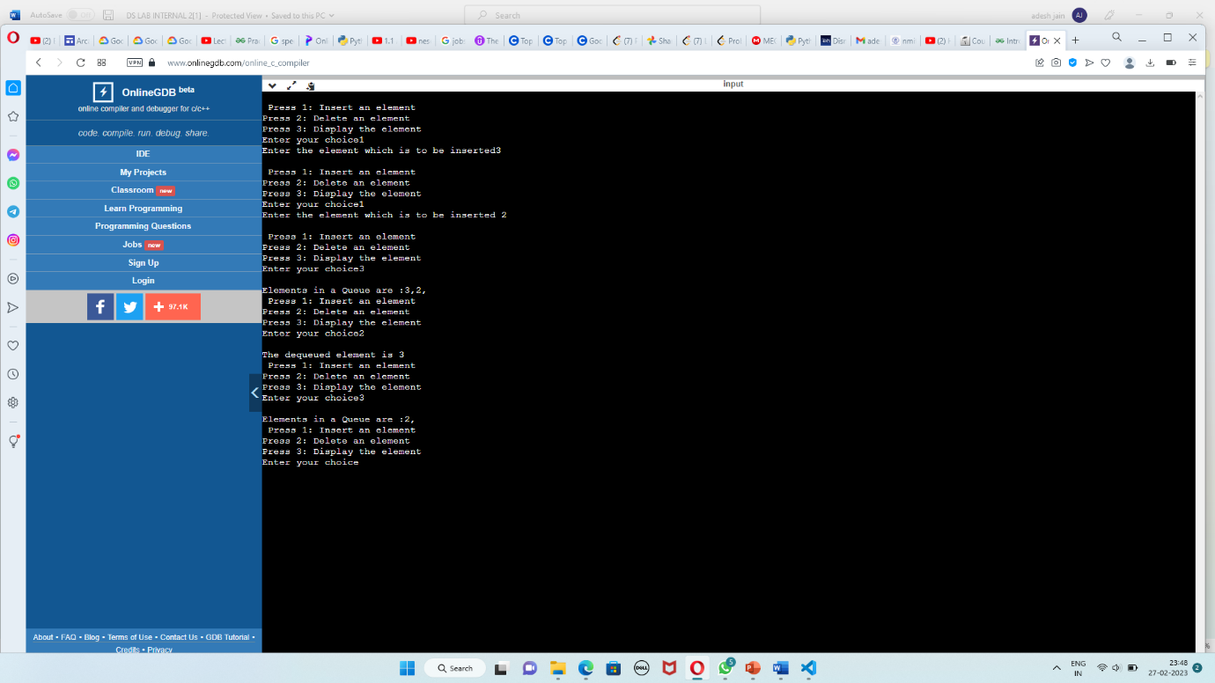

Githublink: <https://github.com/Attulaya/Ds_lab_submission/commit/9cb4e4488c20d482e68659f9147f916f1083dd31>